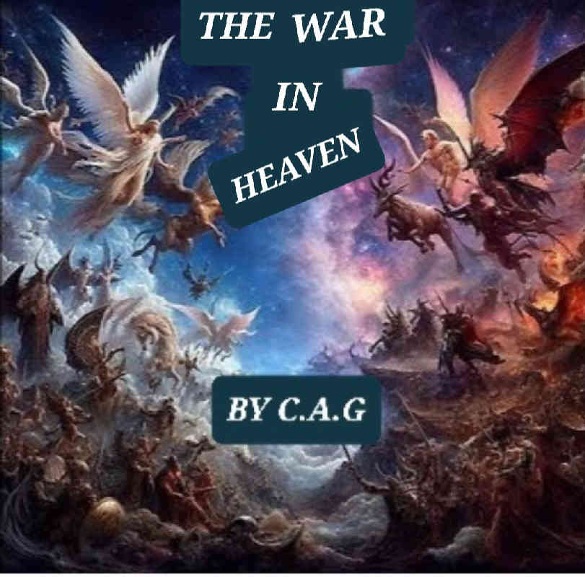

THE WAR IN HEAVEN

PROLOGUE



THE WAR IN HEAVEN

PROLOGUE

And GOD said: let there be light and there was light.

God separated the light from the darkness and created all things.

There are countless versions from the Bible to the Vatican itself.

Thousands of stories have been told to us about God's creation.

What I write in this book is a story about these divine and religious themes, I do not intend to change anything at all.

Reality or fiction I leave it to believers and non-believers, with all due respect.

I, the author C.A.G.

1. EARTHLY PARADISE CHAPTER 1

Page 1

THE WAR IN HEAVEN

EARTHLY PARADISE CHAPTER 1

The kingdom of heaven is full of love, happiness, and coexistence.

God is satisfied with his work.

He has created angels, animals of all sizes, and the human race.

It is an earthly paradise.

Every dawn you can see the light

through the flowers, the brightness and colors of a radiant sun.

Everything is peaceful, the angels enjoy

every day, with their training, their families, and their animals.

They also bathe in the sea, but with care, God has created the leviathan, a giant creature to take care of the sea.

Page 1

1. LOVE OF GOD CHAPTER 2

Page 2

THE WAR IN HEAVEN

LOVE OF GOD CHAPTER 2

Days and years of devotion to God go by.

The angels thank God with their prayers and prayers for the happiness of living

in paradise, everyone brings him offerings.

Everything is prayers, a bright light

appears before the angels and blesses them, in a corner of the temple, there is a shadow with a silhouette, but, nobody gives it importance.

After praying, everyone returns to their tasks. It is morning, some go for a

walk, others go to train with their brand new swords.

Page 2

1. THE MEETING CHAPTER 3

Page 3

THE WAR IN HEAVEN

THE MEETING CHAPTER 3

There is an angel who is no longer happy

with the prayers to God.

He believes that he is better than him, so

he decides to form a secret meeting.

Many legions of angels have always followed him and he trusts that in this

revolt against God, they will also follow him.

He plans to conspire against God and take away

all his power.

He knows that if he succeeds, they will worship him as God.

They are gathered behind some rocks in the desert and he is telling them the plan to attack and when the attack will be.

Everyone knows his name, his name is

Lucifer, also known as the dragon

or Satan.

Page 3

1. THE DEAL CHAPTER 4

Page 4

THE WAR IN HEAVEN

THE DEAL CHAPTER 4

Satan is disturbed, he wants the throne of God, he thinks about making a deal with the good angel named Michael.

He knows that if Michael accepts together they could defeat God.

Satan goes after Michael and when he finds him he says:

Satan: Michael, join me in this conspiracy towards God, together we will defeat him.

Michael: Satan, you don't know what you're saying, if you try I'll stop you, there's no deal.

Satan leaves very disappointed.

Michael doesn't hesitate to contact God, to tell him Satan's plan.

Page 4

1. MEETING WITH GOD CHAPTER 5

Page 5

THE WAR IN HEAVEN

MEETING WITH GOD CHAPTER 5

Miguel goes to visit God, he has to

tell him about Satan's plans.

Miguel starts to pray and a bright light

appears before him, it is God and he already knows

why Miguel has come to see him.

GOD: Miguel, you are the good angel

I believe you so that you will guard the kingdom, I

know why you are good to me.

Satan wants to defeat me but you will stop him and we will expel him from the kingdom to hell.

Miguel: So it will be, Lord, as you say

May your will be done.

Miguel went in search of Satan so that he would surrender and reform himself.

Page 5

1. SATAN AND MICHAEL CHAPTER 6

Page 6

THE WAR IN HEAVEN

SATANAS AND MIGUEL CHAPTER 6

Miguel knows that he has to comply with God's law, he will try to make Satan reform, but he knows that this will be impossible, Satan is crazy.

Miguel finds Satan and tells him:

Miguel: Satan, I have spoken with God

Give yourself up, you can reform and end this rebellion.

Satan: No, I know that the old man does not want that, he would throw me into hell.

I gave you a chance to fight by my side

You will have to pay for it too

Miguel: Stop it Satan and listen.

Satan: No, you are the one who has not listened

We will see each other on the battlefield.

Page 6

1. THE WAR CHAPTER 7

Page 7

THE WAR IN HEAVEN

THE WAR CHAPTER 7

There is no turning back, everything is prepared on the battlefield.

Legions of angels surround him.

There are a multitude of warriors that can hardly be counted, there are countless celestial animals that will fight with their lives, it will be a bloody war.

No one moves. Miguel tries to convince Satan for the last time.

Miguel: Satan, you alone can end all this, give in, surrender and I will help you personally before the creator.

Satan: Fight or retreat, you will suffer my wrath.

Miguel: I understand, then you will suffer the wrath of God, do your will here and now.

Page 7

1. FIRST ASSAULT CHAPTER 8

Page 8

THE WAR IN HEAVEN

FIRST ASSAULT CHAPTER 8

Satan can no longer hold out; he wants to defeat Michael first and then God, so he can have his throne and kingdom.

Satan raises his sword and orders the attack; the rebellious angels head towards the angels faithful to Michael.

Michael also responds to the attack.

It is being a tough battle; there is heavenly blood everywhere. There are already long hours of combat; on Satan's side a horn is heard announcing the retreat.

It is a strategy of Satan to attack again. Michael raises his sword and orders, rest, once Satan has retreated. Michael knows that he will return.

Page 8

1. COUNT AND CASUALTIES CHAPTER 9

Page 9

THE WAR IN HEAVEN

RECORD AND CASUALTIES CHAPTER 9

It is nighttime, the two armies are

counting the losses and the casualties of angels.

Satan is clever and is thinking how to counterattack.

Miguel knows how Satan works, that is why

He tries to see where he will attack again.

It is dawning, the radiant sun shines with the blood spread on the ground

of the battlefield.

The two armies are already standing for a new battle.

They look at each other, there are dead angels and animals everywhere.

Satan orders the attack again.

Page 9

1. SECOND ASSAULT CHAPTER 10

Page 10

THE WAR IN HEAVEN

SECOND ASSAULT CHAPTER 10

Miguel has been smarter than Satan.

At night he has moved his army to create a trap for Satan.

He wants to lead him to a ravine in the form of a bottleneck, he knows that there he will win the war.

The battle is being very hard, not even Satan, as clever as he is, has realized Miguel's plan.

Miguel's army has cut off the rearguard of Satan's army so that they can advance to the trap. Miguel has divided his army into two parts, the plan is working, the retreat horn sounds and Satan advances to the trap.

Page 10

1. MASTER AND WISE MAN CHAPTER 11

Page 11

THE WAR IN HEAVEN

MASTER AND WISE MAN CHAPTER 11

Miguel is a master and wise man in the art of war, that is why God put him to guard the Kingdom.

Satan is resting in the ravine

with his army inside the ravine.

The space of land is so big that it does not look like a ravine.

Everyone is sleeping only the song of the celestial cricket can be heard, on the other hand the army of

Miguel is also sleeping.

Miguel is thinking about the final blow

The ravine has high walls and Miguel has sent his archers to the highest

high to launch their arrows against Satan's army.

Page 11

1. THE LAST ASSAULT CHAPTER 12

Page 12

THE WAR IN HEAVEN

THE LAST ASSAULT CHAPTER 12

Satan orders the attack, Michael's army leads Satan's army to the bottleneck, the archers begin to shoot their arrows, there is no way out or retreat for Satan. The rebel angels begin to fall.

Satan sees himself lost and does not understand what is happening. His army is falling and he has no chance of winning the war. Satan and Michael fight with their swords. The confrontation is tough in which Michael emerges victorious and stops Satan. The few rebel angels who are still standing surrender, seeing Satan imprisoned. It is the end of the war.

Page 12

1. THE JUDGMENT CHAPTER 13

Page 13

THE WAR IN HEAVEN

THE JUDGMENT CHAPTER 13

Satan is brought before God to be judged, he is placed in a circle

surrounded by salt, he is also guarded by guardian angels.

A bright light appears in the room

it is God, he is going to judge Satan for his evil deeds and his bad faith.

GOD: Satan, your own pride condemns you, you will go to hell on earth

and so that you are recognized you will wear

horns and a tail, just like your rebels.

Satan: someday I will take revenge, I will return

and I will dethrone you.

As if it were an act of magic, Satan

changed his appearance and disappeared.

Page 13

1. HELL CHAPTER 14

Page 14

THE WAR IN HEAVEN

HELL CHAPTER 14

Satan is already in hell on earth

if his appearance has changed as God told him. He is chained and locked up with his rebellious angels, who are now demons.

The door to hell is sealed by the divine power of God, there is no escape

and there is no possible escape.

Satan only thinks about how to get out of there

he thinks about how to take his revenge, and,

he thinks about possessing human beings as well.

For now he has to rest

the war has weakened him, as has divine faith.

Page 14

1. PEACE AND LOVE CHAPTER 15

Page 15

THE WAR IN HEAVEN

PEACE AND LOVE CHAPTER 15

Peace returns to the earthly paradise, the sun shines brightly among the flowers of the battlefield, because they are reborn from that

Darkness.

God is satisfied with Michael's victory and with his faith in him.

The angels return to everyday life

in the kingdom.

They continue training for future battles.

A party is organized in memory of

God and he presents himself to them and says :

God : never be afraid

always pray in my name because I will send my son Jesus to

preach my word.

THE END

Page 15

1. EPILOGUE

THE WAR IN HEAVEN

EPILOGUE

In this work I want to create a fiction

as close to reality as possible.

I do not want to take the Bible out of context as much as many Catholic books already written.

What I do is perhaps more of a script for a movie, but I leave it to the readers to judge according to their knowledge

of the Catholic religion and the Bible.

I hope you like this story.

I am the author: C.A.G

EPILOGUE